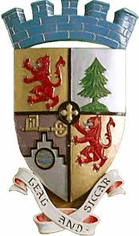

All Ballater and Crathie residents are welcome

Ballater & Crathie Community Council

Public Meeting – Ballater Old School Development

Meeting Objective is to agree the position that BCCC is to take

in a proposed meeting to GHA to discuss the

Old School Development

www.ballaterandcrathiecommunitycouncil.com

Monday, 26th Nov, 2018, 7 pm to 9 pm

Mike Sheridan Room, Ballater.

AGENDA
- Welcome and Apologies
- Introductions and Declarations of Interests
- Confirm Meeting Objective
- Agree priorities for discussion, eg;
Access, density, allocation of properties, other
- Discuss different scenarios, discuss merits of each
- Agree position to take with GHA
Tactics – which scenario is preferred, is there a priority
Attendees -

Meeting is not a discussion on whether BCCC should raise legal appeal – this was agreed at 11th November meeting that residents to look into appeal.

